PRACTICAL - 5

Aim: Write a program to implement single layer Perceptron in Java.

Tools: Java language is used to execute this program.

Algorithm/Theory:
The Perceptron is a kind of a single-layer artificial network with only one neuron. It is a network in which the neuron unit calculates the linear combination of its real-valued or boolean inputs and passes it throug

Input:

X1, X2, t (target values) and bin are the inputs of the single layer perceptron algorithm.

Program Code:

import java.util.*;

class Perceptron
{
public static void main(String args[])
{
int w1=0,w2=0;
int b=0,c=0;
int x1[]={1,-1,1,-1},x2[]={1,1,-1,-1},t[]={1,-1,-1,-1},bin[]={1,1,1,1};
int alpha=1,theta=0;
int yin[]=new int[4];
int y[]=new int[4];
System.out.println("x1 x2 t bin yin y w1 w2 b");
while(true)
{
for(int i=0;i<4;i++)
{
yin[i]=(bin[i]*b)+(x1[i]*w1)+(x2[i]*w2);

if(yin[i]>theta)
{
y[i]=1;
}
else if(yin[i]<=theta && yin[i]>=(-theta))
{
y[i]=0;
}
else if(yin[i]<(-theta))
{
y[i]=-1;
}

if(t[i]!=y[i])
{
w1=(w1+(alpha*t[i]*x1[i]));
w2=(w2+(alpha*t[i]*x2[i]));
b=b+(alpha*t[i]);

System.out.println(""+x1[i] +" "+x2[i] +" "+t[i]+" "+bin[i]+" "+yin[i]+" "+y[i]+" "+w1+" "+w2+" "+ b+"");
}

}
c++;
if(c==5)
{
break;
}

}
System.out.println(""+x1[3] +" "+x2[3] +" "+t[3]+" "+bin[3]+" "+yin[3]+" "+y[3]+" "+w1+" "+w2+" "+b+"");

}
}

Output:

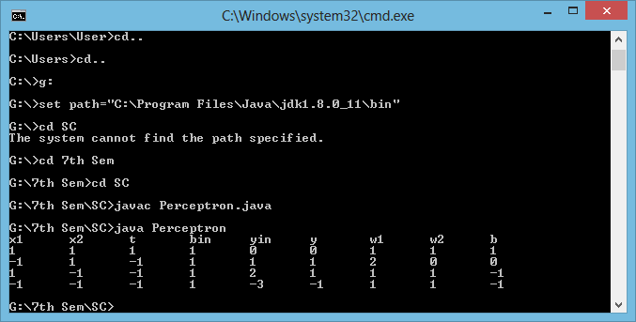

Architecture:

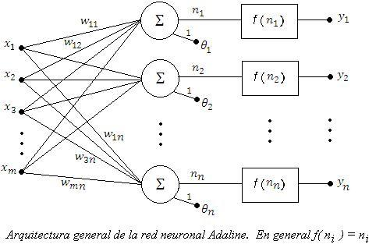

Conclusion:

Hence we have performed this practical successfully in java.

